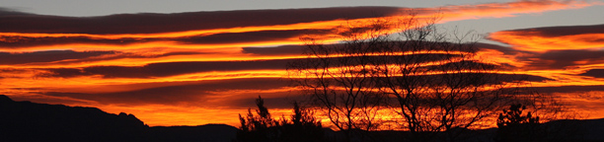
Shades of the Southwest – A Juried Exhibit
Gail Garber and Donna Barnitz are curating a special exhibit, “Shades of the Southwest”, for the American Quilter’s Society QuiltWeek® Show. It will take place in Albuquerque, NM January 14-17, 2015. We seek a wide variety of quilts that interpret this theme.
There are no size or age requirements for this exhibit which will include 30 quilts to be displayed at this show. Additionally, there is no entry fee.
However, quilts that are accepted into the show must be delivered to Ann Silva’s Bernina Sewing Center in Albuquerque, NM prior to January 1, 2015. They will then either need to be picked up in Albuquerque following the show, at Bernina Sewing Center, or shipped back to the owner by AQS for an additional fee. Shipping information will be provided for accepted quilts. Quilts returned via shipping will be returned by February 15, 2015.
Entries are due no later than November 1, 2014. Quilters, whose quilts are accepted for the exhibit will be notified by November 10, 2014.
No more than two entries will be accepted from one individual.
Please complete the Entry Form and email it, along with two high-resolution, digital images (at least 1080 pixels on one side). One image should show the entire quilt and the second should show a close up.
Questions? Contact gail@hawksaloft.org or donnabarnitz@yahoo.com

